70th Melbourne Gang Show,

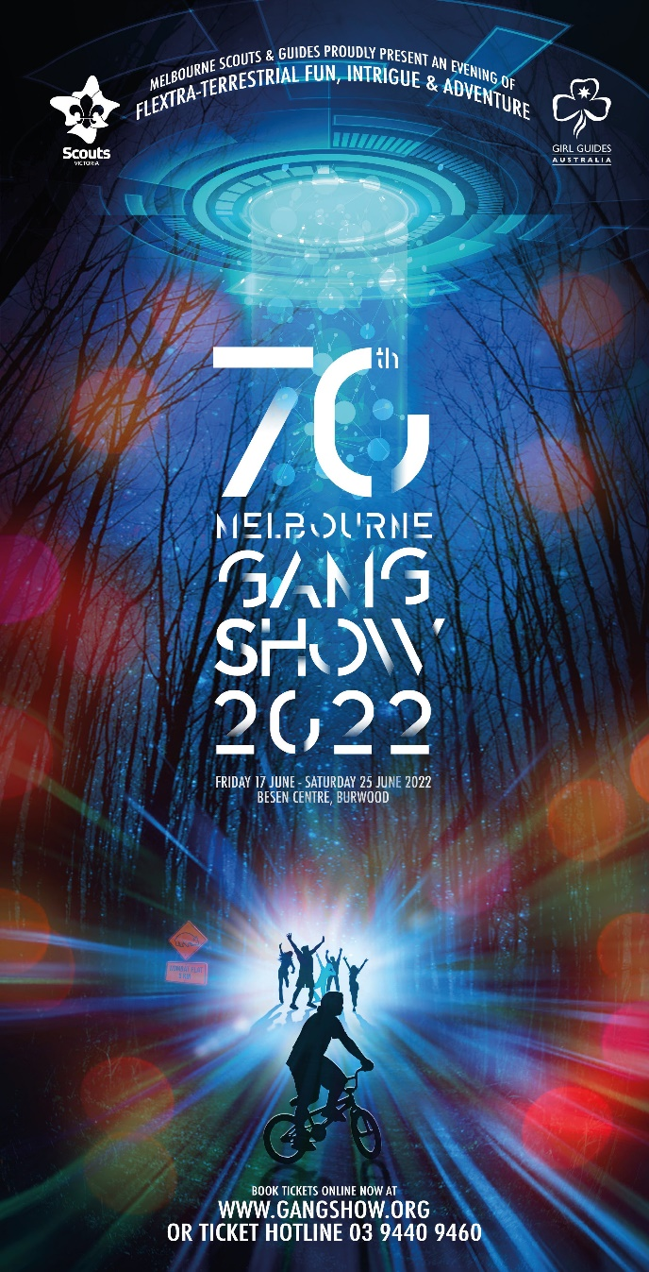
Family BBQ, Cub Sleepover!

The Scouts and Guides of Victoria present the 70th Melbourne Gang Show, at the Besen Centre, Burwood.

See also: http://www.gangshow.org

Rosanna Cubs (AND parents, siblings etc., all welcome too!) will attend the 2pm performance on Saturday, 18th of June.

Following the performance, we’ll be coming back to the Hall for a family BBQ, and then the Parents and siblings will leave and the Cubs will have a sleepover.

This Year we’ll again be inviting 1st Bendigo Cubs, to come along to our BBQ and Sleepover after Gang Show!

Costs for the performance (group discount) and afterwards:
- Adults/Children: $20
- Family BBQ: $5 per person
- Cub Sleepover: $5 per Cub

We need to get our bookings in for the show as soon as possible, to enable us to get the best possible seats at the performance. Once we’ve put the booking in, you may still be able to buy tickets for the performance, but you may be seated elsewhere in the theatre and the ticket prices will be higher, due to missing the group discount.

Please return the tear off form – RETURN IT with money (cash please) by Tue 17th May, BUT please email me now at akela@rosannacubs.org ! We’ll then get tickets organised.
Come along and have a ball!

70th Melbourne Gang Show, 2022
We’re coming along….
(1) Family Name:______________________ Youth Member(s):____________________

(2) TOTAL tickets required (Youth members & Family): _____________ x $20 = $____

(3) Attending the BBQ? Adults: _________ + Children: _________ = Tot:_________ x $5 = $____

(4) Cub(s) staying for sleepover – Name(s): _____________________________ x $5 each = $____

Money required 17/5, so we can get tickets. Total: = $_____
Please no Cheques or Transfers… CASH ONLY!

Please email NOW re Gang Show numbers, to akela@rosannacubs.org If unable to attend, please email to let us know.

